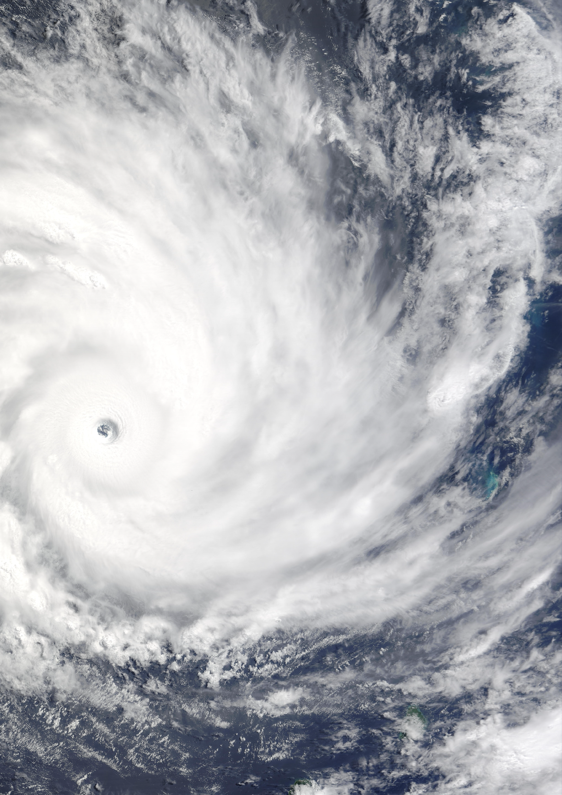

Hurricane Preparedness Tips

www.bcmgbrokers.com

Forecasters at NOAA’s Climate Prediction Center, a division of the National Weather Service, are predicting above-average hurricane activity this year
— which would make it the seventh consecutive above-average hurricane season. NOAA’s outlook for the 2022 Atlantic hurricane season, which extends from June 1 to November 30, predicts a 65% chance of an above- normal season, a 25% chance of a near-normal season and a 10% chance of a below-normal season.

For the 2022 hurricane season, NOAA is forecasting a likely range of 14 to 21 named storms (winds of 39 mph or higher), of which 6 to 10 could become hurricanes (winds of 74 mph or higher), including 3 to 6 major hurricanes (category 3, 4 or 5; with winds of 111 mph or higher). NOAA provides these ranges with a 70% confidence

It's Hurricane Season

The annual hurricane season began June 1 and runs until November
30. Though the COVID-19 pandemic continues to have a deleterious impact, one cannot overlook the necessary steps that need to be taken now to ensure you are FULLY PREPARED.

Certainly as you observe current Social distancing guidelines, you will also need to prepare for what every model and forecaster concludes will be an abnormally busy year as outlined below:

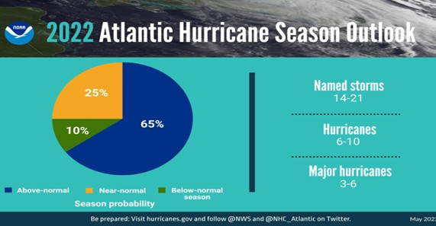

Source: National Oceanic and Atmospheric Administration

The West African monsoon season produces complexes of thunderstorms that travel west and move over the eastern Atlantic Ocean. These clusters of storms, or waves, are the seeds from which many named storms form at the height of the hurricane season.

A hurricane needs warm waters, moist air, low wind shear, and intense thunderstorms in order to develop and strengthen. The 2022 forecast from both NOAA and Colorado State University rely on a combination of factors including:
- Low wind shear;
- Warm ocean temperatures; and
- An increase in tropical waves moving off the western coast of Africa

- Alex
- Bonnie
- Colin
- Danielle
- 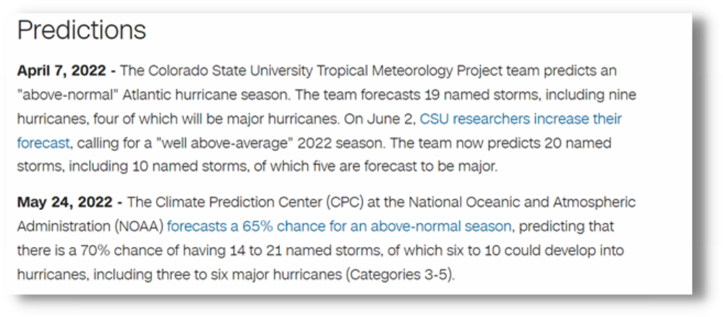Earl
- Fiona 7.Gaston 8.Hermine 9.Ian 10.Julia
- Karl
- Lisa
- Martin
- Nicole
- Owen
- Paula
- Richard
- Shary
- Tobias
- Virginie
- Walter

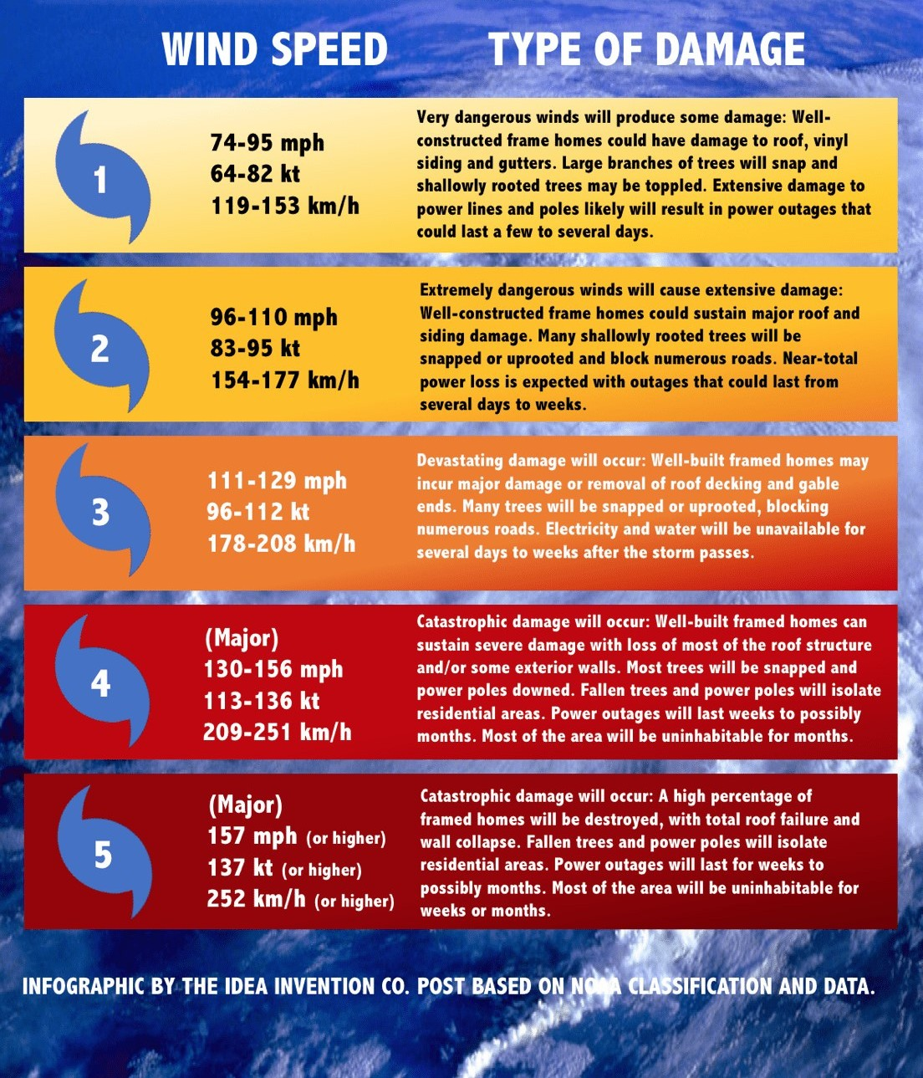The Saffir-Simpson Hurricane Scale help us to understand different hurricane wind speed that exists and the associated damages with each category. The below summarises this:

Hurricane Action Plans should consider the following:

Planning Prior to the hurricane
Tropical Storm or potential hurricane.
(storm is named)

Hurricane watch
(Typically 48 hours before the hurricane makes landfall.)

Hurricane Warning
(Typically 24- 36 hours before the hurricane makes landfall.)
Hurricane Recovery (Following a hurricane)

Ensure your assets are insured for their correct replacement values. This will prevent the application of the average-under- insurance clause.

PRE-SEASON CHECKLIST
Have you renewed your insurance policy/ies? Have you paid your insurance premium?

Disinfectant | Household bleach | Antiseptic toilet paper | Soap
|Feminine supplies | Personal hygiene products | Plastic buckets with tight lid.

Check your roof and correct all leaks before the start of the hurricane season.

BE PREPARED! ACTIVATE YOUR
HURRICANE SENSES NOW

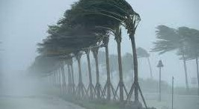Have adequate supply of batteries for flashlights |Kerosene for lanterns

PRE-SEASON CHECKLIST
| Fuel for generators | Ensure portable light devices are fully charged.

Nails |Ply-board |Shutters| Ropes| Duct tape [for windows] | Plastic bags Plastic | Storage containers | Can opener | Sand bags | Car covers
- Branches touching power lines MUST be trimmed.
- Branches hanging too close to your house/your neighbours' house/ commercial building MUST be trimmed.
- Branches that seem compromised or weakened MUST be trimmed.

BE PREPARED! ACTIVATE YOUR
HURRICANE SENSES NOW

- Ensure your second gas cylinder is replenished.

PRE-SEASON CHECKLIST
- Ensure coal for stove is wrapped in plastic bags.
Stock up on non-perishable food items – at least seven (7) days’ supply of ready to eat canned meats, fruits and vegetables, crackers, jams, canned and bottled juices.

At least one (1) gallon of water per day per person for personal use. As much as possible for sanitation purposes to reduce/eliminate odor.
This is to be fully replenished with iodine | Adhesive bandages| Eye lotion |Pain medicine | Sterile gauze pads| Rubbing alcohol | Assorted safety pins | Cotton | Needle & thread

BE PREPARED! ACTIVATE YOUR
HURRICANE SENSES NOW

IMPORTANT DOCUMENTS

PRE-SEASON CHECKLIST
Store documents in waterproof containers [such as plastic bags; containers / vaults]
At least one family member should know how to administer CPR. CPR is a lifesaving technique useful in many emergencies, including heart attack/near drowning, in which someone's breathing or heartbeat has stopped.

Make plans with your pets in mind - Prepare a pet emergency kit for your
animals. Ensure that they are placed in a dry and secured area; safe from flood waters, excessive wind and flying debris.

Generator area should be well ventilated and a safe distance from house/office

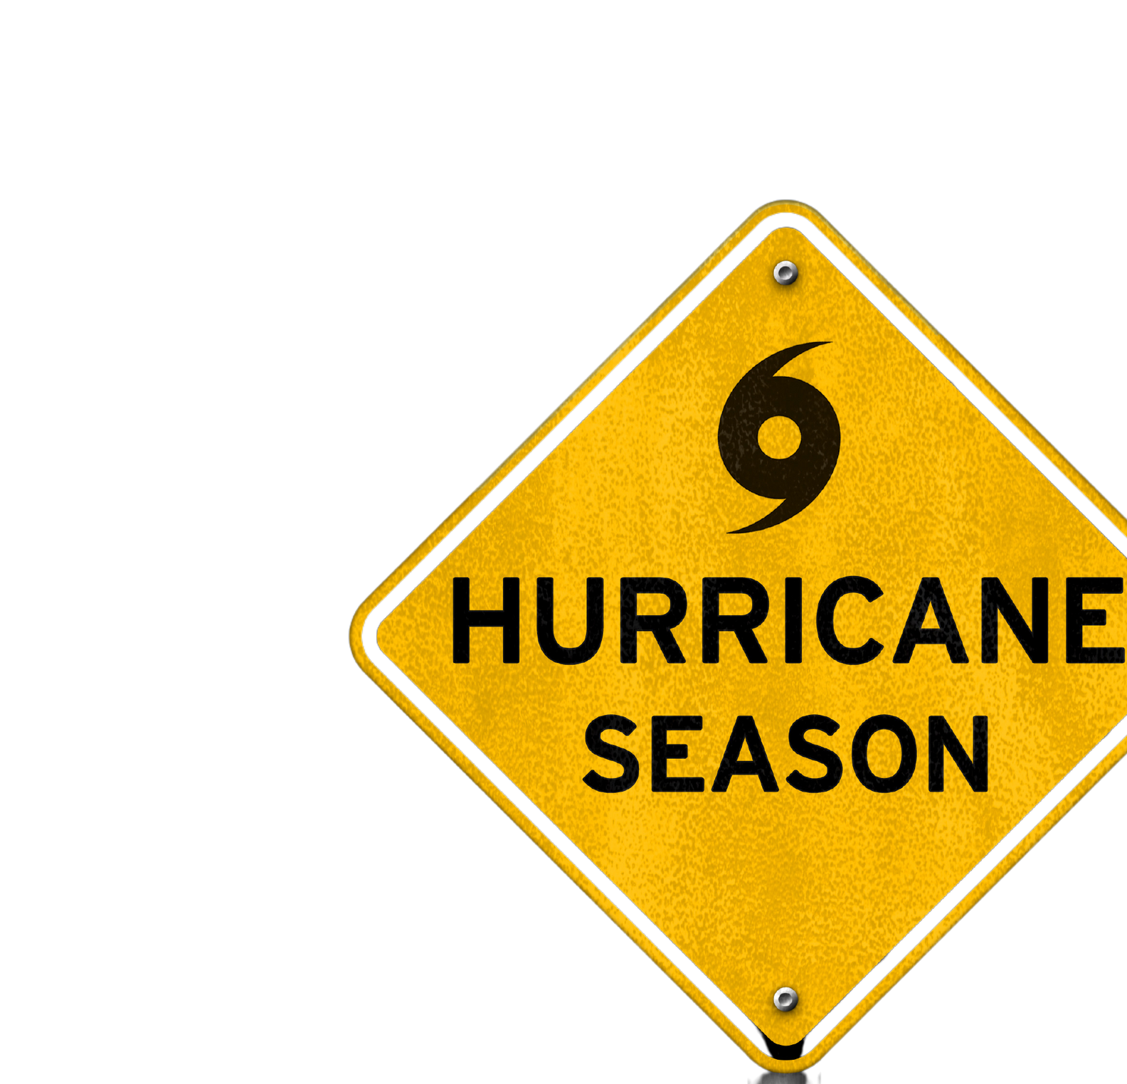
Review your Hurricane action
1.

Have a storm tracker monitor the weather
2.
3.
4.
5.
6.

Stop all deliveries (Where applicable)

Have subcontractors move any uninstalled materials to a safe location.

Discontinue work on projects that are vulnerable to damage and secure all material

Close all doors and windows

Remove, secure, isolate or neutralize chemicals.
7.

Move important documents and records to a safe location
8.

Ensure trailers and shipping continuers are properly anchored and tied down.
10
9.

Consider preparation to prevent water damage to the structure eg. Sandbagging.

Ensure there are adequate supplies for on site emergency personnel
Fully charge all devices and batteries
11.
12
13

Ensure all evacuation routes are open

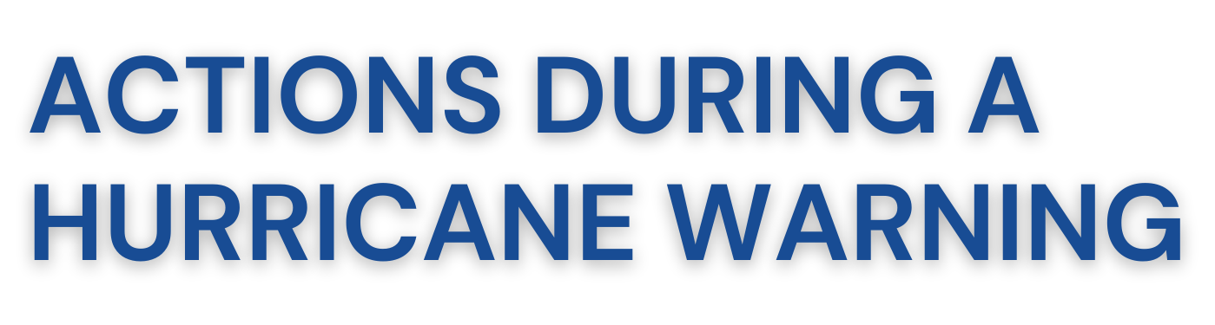

Secure all exterior building openings, doors and windows. Consider temporary bracing for large doors which are not designed for high wind loads.
1.

Back up all important critical computer data. Store data backup offsite.
2.
3.
4.

Unplug and move computers to as high an elevation as possible, in the middle of a room and away from windows, or cover items which cannot be moved.

De-energize power (especially temporary electrical service) at the circuit breakers, as close to the main power breaker as possible.

Shut down all gas lines as far back to the main

Shut down all water lines that are not used for fire protection
5.
6.

Consider having cash available for recovery operations.
7.

Fuel all vehicles and emergency equipment
8.

Establish a meeting place, if possible, for key recovery members
9.
If agreements exist for recovery assistance by Contractors, contact them to plan recovery efforts.
10

Make a video/photographic record of the surrounding properties to document the condition prior to the storm.
11.

1. Despite the disruptive nature of the event, before making repairs, ensure that all safety procedures have been implemented
2.
3.

Always ensure that a safety manager is present prior to beginning a hurricane recovery operation

Determine if the location is safe to enter and what hazards are present. Also, determine what personnel should return to the location.

Determine what medical facilities are currently handling emergencies in the event of an injury.

Recovery personnel must be equipped with appropriate personal protective equipment (PPE).

Maintain proper first aid equipment and clean water to aid in disinfection.
4.
5.
6.
7.
8.

Evaluate structures before entering (if required, utilize a structural engineer). Repairs may be required to make the structure safe prior to entry.

Contact your insurance claims office

Document damages in writing, using photos or videos if necessary.
10
11.
9.
12.
13

Barricade and clearly identify unsafe areas to prevent entry. If a barricade is not feasible, post a guard to prevent unauthorized entry until the hazard is eliminated.

Notify the owner and insurer before making repairs. However, make immediate reasonable repairs to minimize damage or prevent personal injury.

If power lines are down, consider them as energized “live” until verified to be de-energized. Beware of electrical lines in standing water.

When operating fuel-powered equipment such as generators, pumps, compressors, etc, ensure that proper ventilation is provided.

The following definitions are critical to understanding hurricanes and their impact on construction projects:

Hurricane Season
The portion of the year having a relatively high incidence of hurricanes. The hurricane season in the Atlantic, Caribbean, Gulf of Mexico, Central Pacific basin runs from June 1 to November
30. The hurricane season in the Eastern Pacific basin runs from May 15 to November 30.

Hurricane / Typhoon
A tropical cyclone in which the maximum sustained surface wind (using the U.S. 1 - minute average) is 74 mph (64 knots) or more. The term 'hurricane' is used for Northern Hemisphere tropical cyclones east of the International Dateline to the Greenwhich Meridian. The term 'typhoon' is used for the Pacific tropical cyclones north of the Equator and west of the International Dateline.

Hurricane Warning
An announcement that hurricane conditions (sustained winds of 74 mph or higher) are expected within the specified coastal area. Because hurricane preparedness activities become difficult once winds reach tropical storm force, the hurricane warning is issued less than 24 to 36 hours in advance of the anticipated onset of tropical storm- force winds.

Major Hurricane
A hurricane that is classified as Category 3 or higher.

Potential Hurricane
When a storm is named and becomes a Tropical Storm (as defined for the purposes of this guide.)

Storm Surge
An abnormal rise in sea level accompanying a hurricane or other intense storm, and whose height is the difference between the observed level that would have occurred in the absence of the cyclone. Storm surge is usually estimated by substracting the normal or astronomic high tide from the observed storm tide.

Tropical Depression
An organized system of persistent clouds and thunderstorms with a closed, low - level circulation and maximum sustained winds of 39 to 73 mph (34 to 63 knots).

**Source is the National Oceanic and Atmospheric Administration (NOAA) National Hurricane Centre.

KEEP SAFE THI S
HU RRI CANE SEASON.
REM EM BER YOU R BCM G FAM I LY I S HERE FOR YOU .

Stay Connected:
BCMG Insurance Brokers Limited
Suite 1, Fairview Office Park, Alice Eldemire Drive, P.O. Box 214, Montego Bay, Jamaica, W.I. Tel: 876-952-5070

Seaview Ave Office 17 Seaview Avenue Kingston 6, Jamaica, W.I. Tel: 876-929-1982

14 ½ Ripon Road Kingston 5, Jamaica, W.I. Tel: 876-929-7240

www.bcmgbrokers.com

